Nama : Aditya Rahman Syach

NIM : 1247050069

MK : Algoritma dan Pemrograman

Latihan 7.2

Latihan 7.2.1

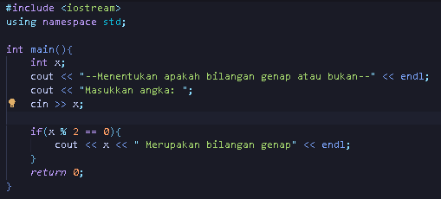

OUTPUT



Latihan 7.2.2

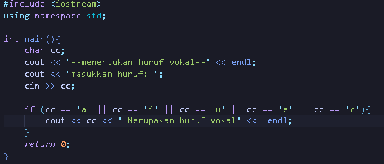

OUTPUT



Latihan 7.2.3

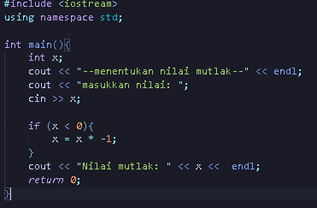

OUTPUT



Latihan 7.3

Latihan 7.3.1

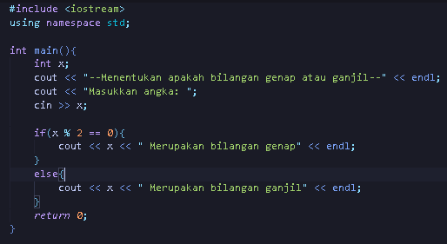

OUTPUT



Latihan 7.3.2

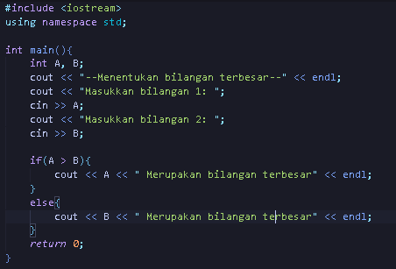

OUTPUT



Latihan 7.3.3

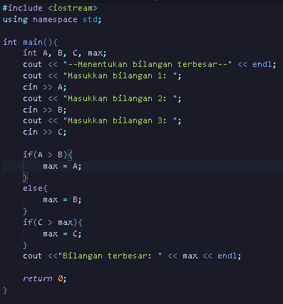

OUTPUT

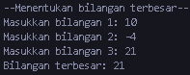

Latihan 7.3.4

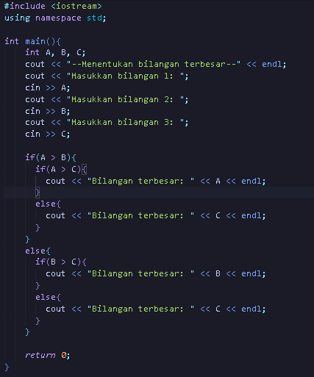

OUTPUT

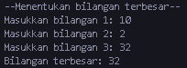

Latihan 7.3.5

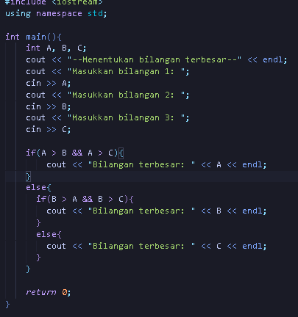

OUTPUT

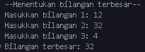

Latihan 7.3.6

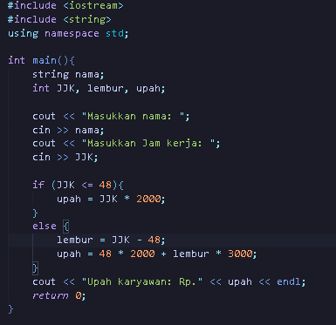

OUTPUT



Latihan 7.3.7

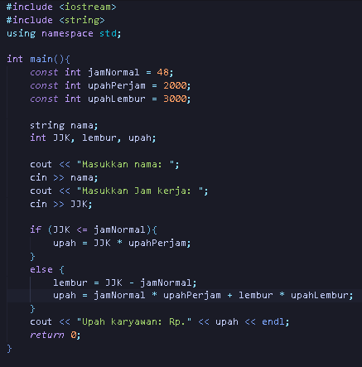

Output:



Latihan 7.3.8

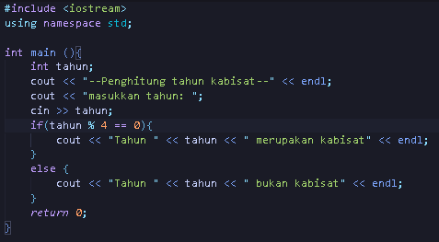

Output:



Latihan 7.3.9

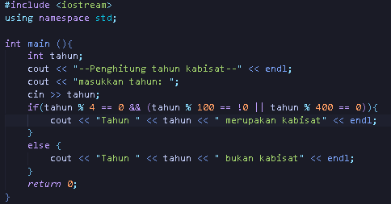

Output:



Latihan 7.4

Latihan 7.4.1

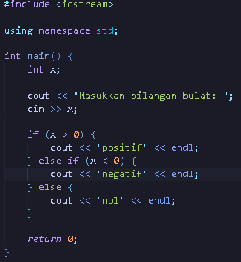

Output:



Latihan 7.4.2

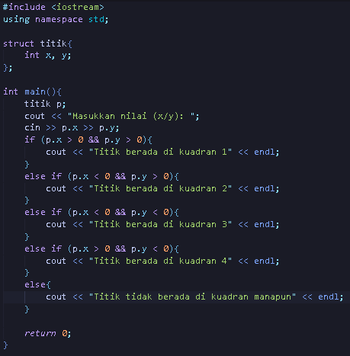

Output:



Latihan 7.4.3

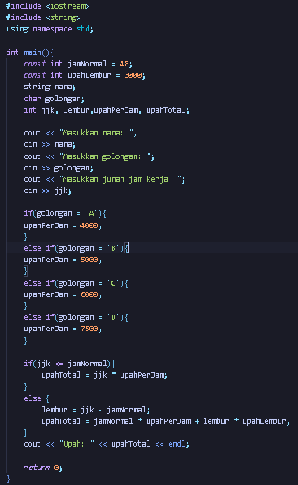

Output:



Latihan 7.4.4

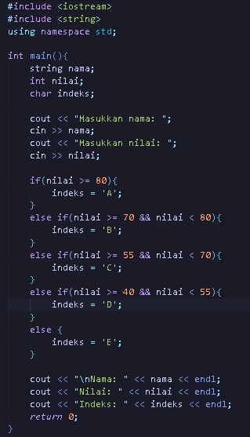

Output:

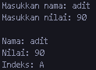

Latihan 7.4.5

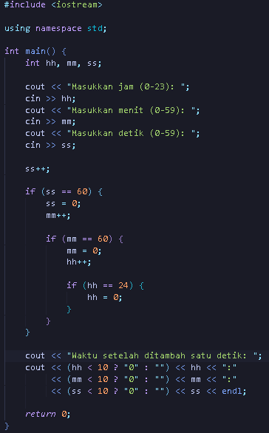

Output:



Latihan 7.5

Latihan 7.5.1

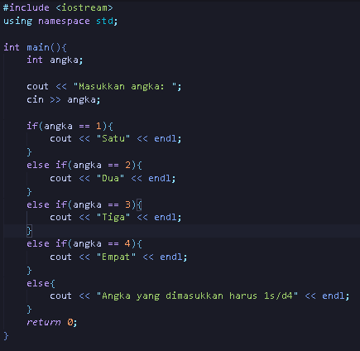

Output:



Latihan 7.5.2

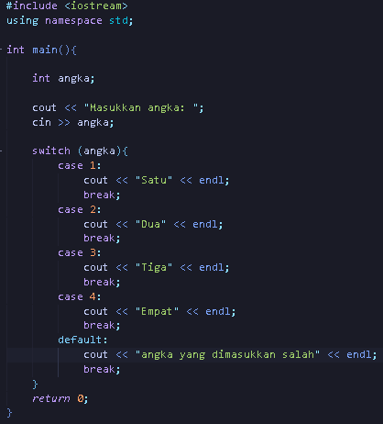

Output:



Latihan 7.5.3

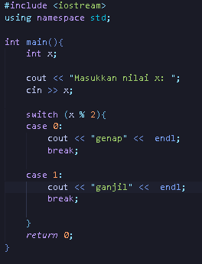

Output:



Latihan 7.5.4

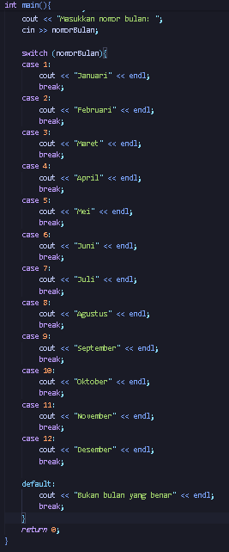

Output:



Latihan 7.5.5

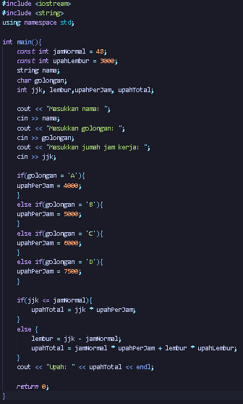

Output:



Latihan 7.5.6

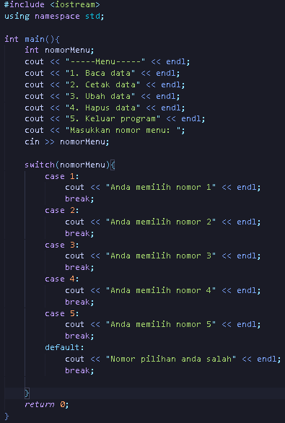

Output:

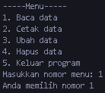

Latihan 7.5.7

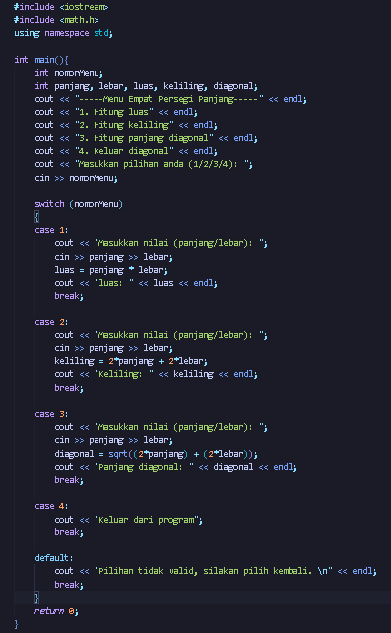

Output:

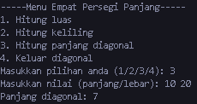

Latihan 7.6

Latihan 7.6.1

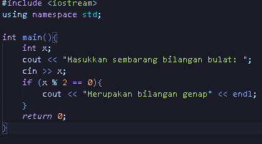

Output:



Latihan 7.6.2

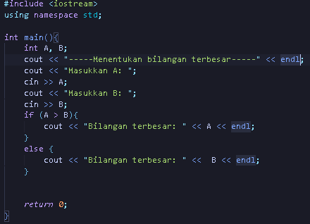

Output:



Latihan 7.6.3

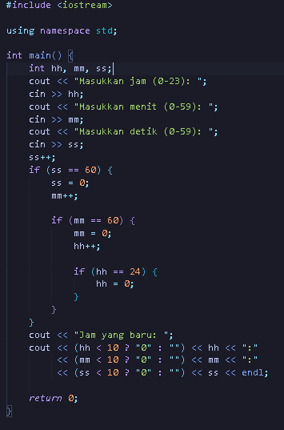

Output:



Latihan 7.6.4

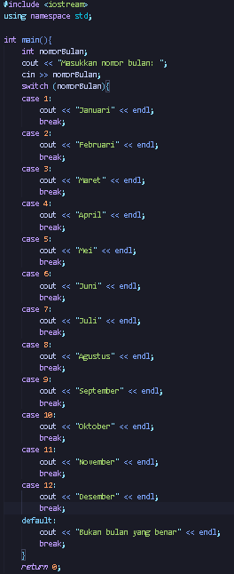

Output:



Latihan 7.6.5

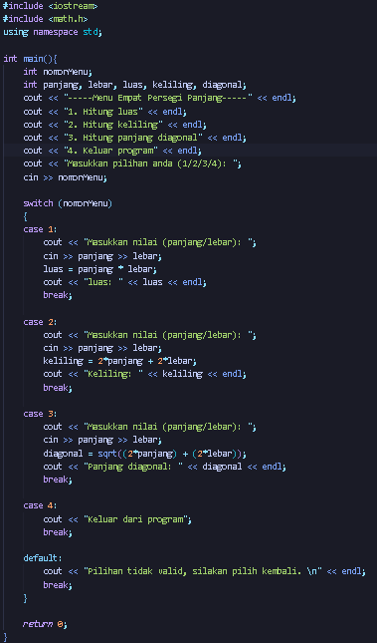

Output:

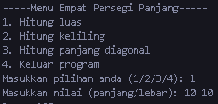

Latihan 7.6.6

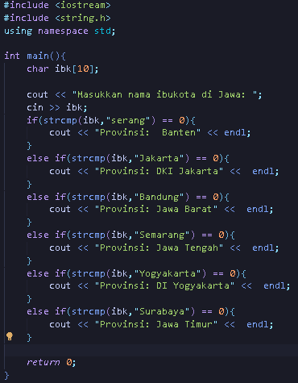

Output:



Latihan 7.6.7

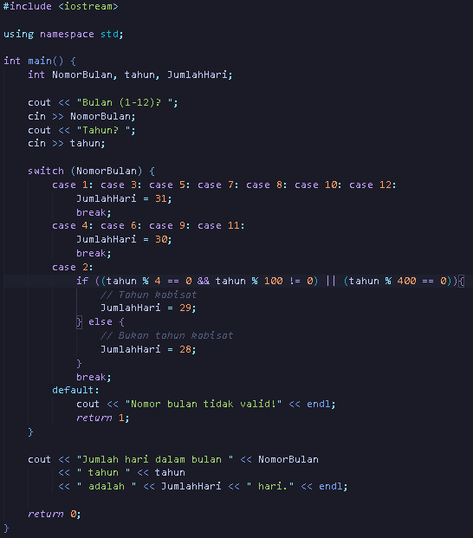

Output:



Latihan 7.7

Latihan 7.7.1

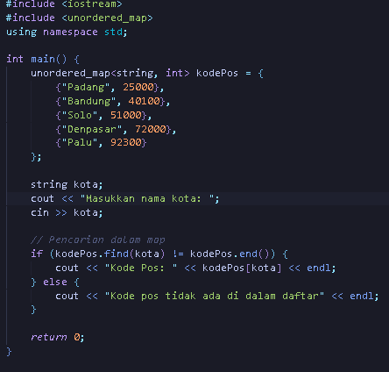

Output:



Latihan 7.7.2

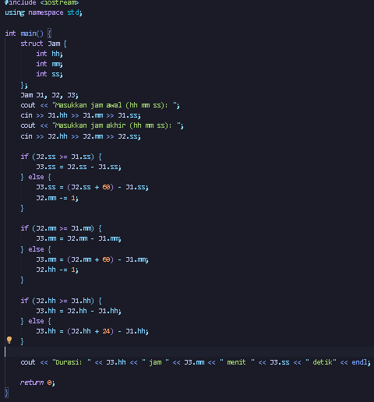

Output:



Latihan 7.7.3

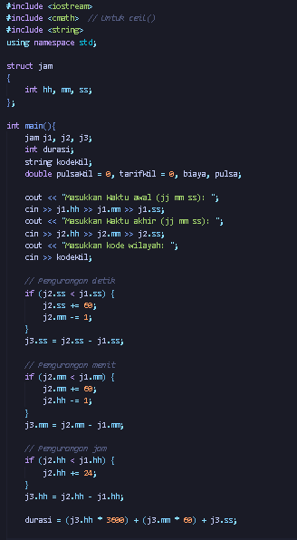

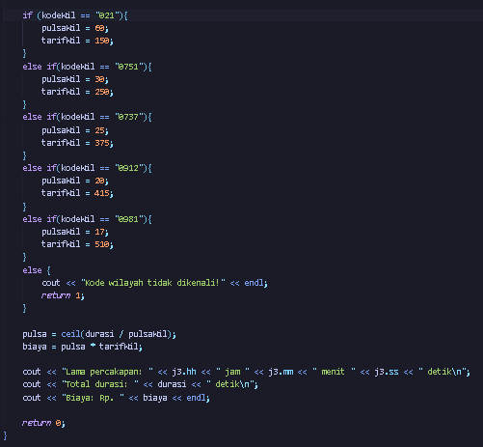

Output:

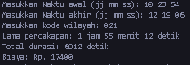

Latihan 7.7.4

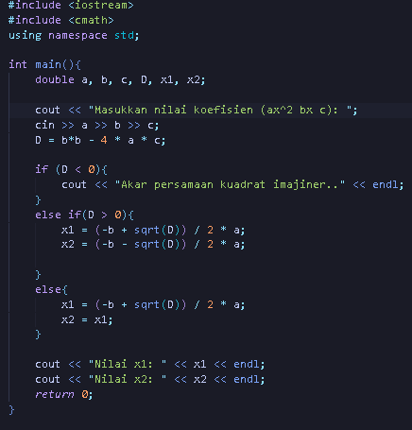

Output:



Latihan 7.7.5

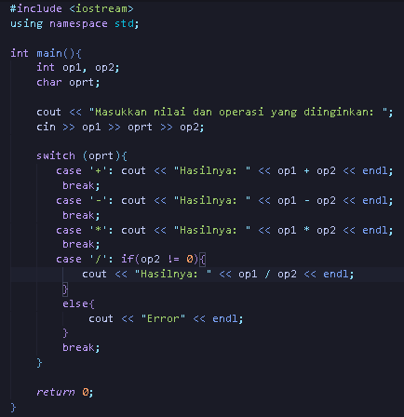

Output:



Latihan 7.7.6

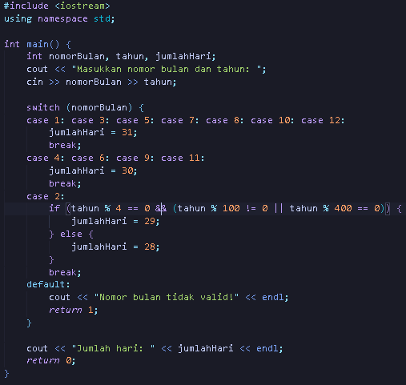

Output:



Latihan 7.7.7

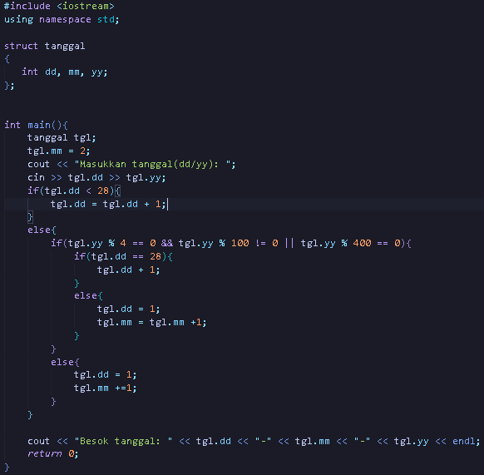

Output:



Latihan 7.7.8

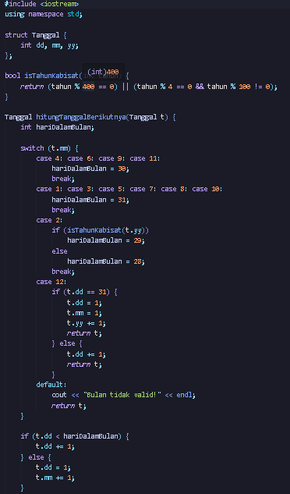 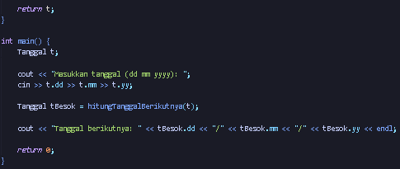

Output:



Soal Latihan BAB 7

SOAL 1

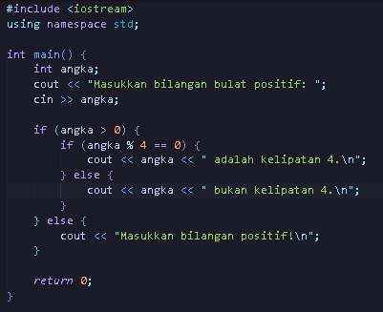

OUTPUT



SOAL 2

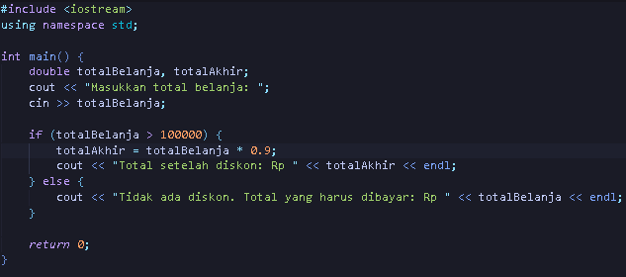

OUTPUT



SOAL 3

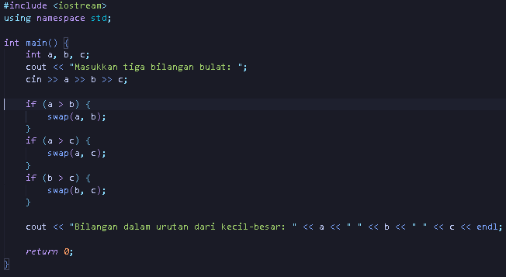

OUTPUT



SOAL 4

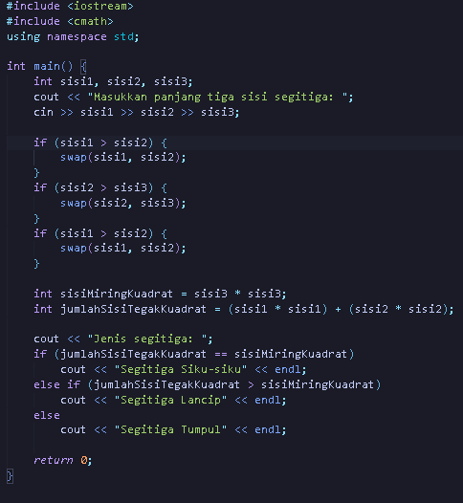

OUTPUT



SOAL 5

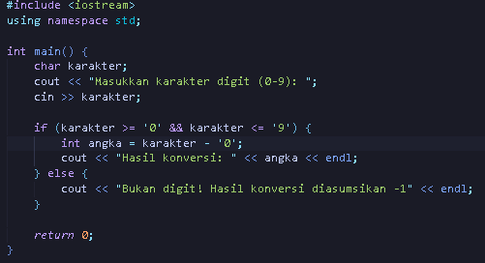

OUTPUT



SOAL 6

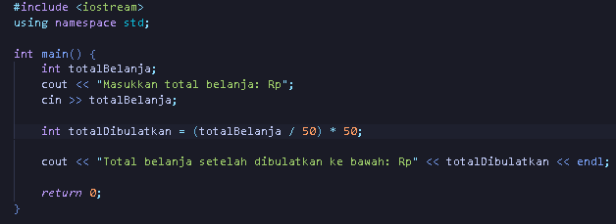

OUTPUT



SOAL 7

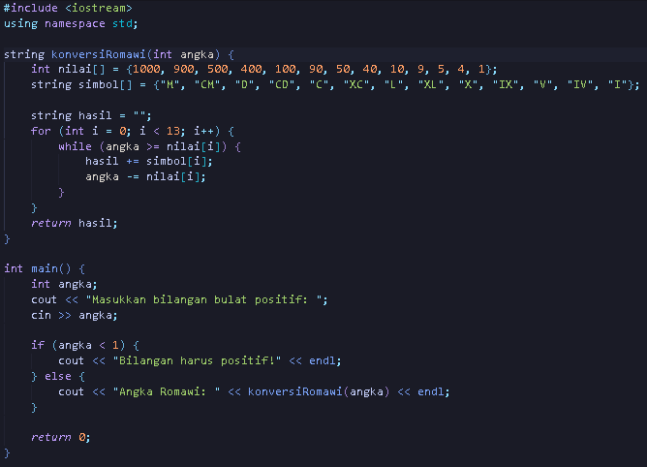

OUTPUT



SOAL 8

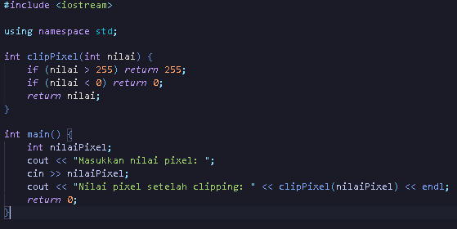

OUTPUT



SOAL 9

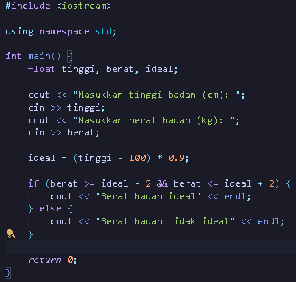

OUTPUT



SOAL 10

Nomor 10 tidak dikerjakan karena baru belajar Bahasa c++ sementara Bahasa C dan pascal belum dipelajari

SOAL 11

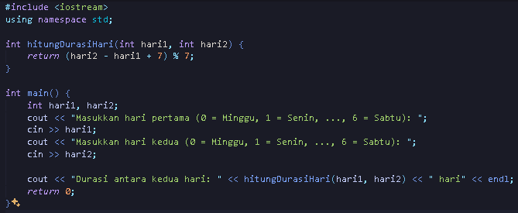

OUTPUT



SOAL 12

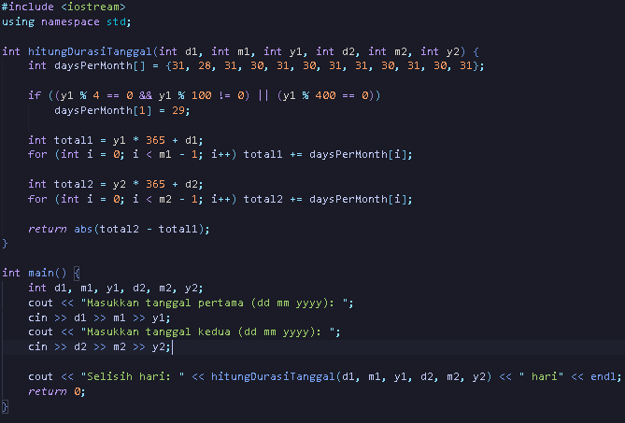

OUTPUT



SOAL 13

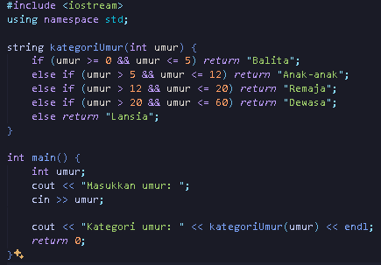

OUTPUT



SOAL 14

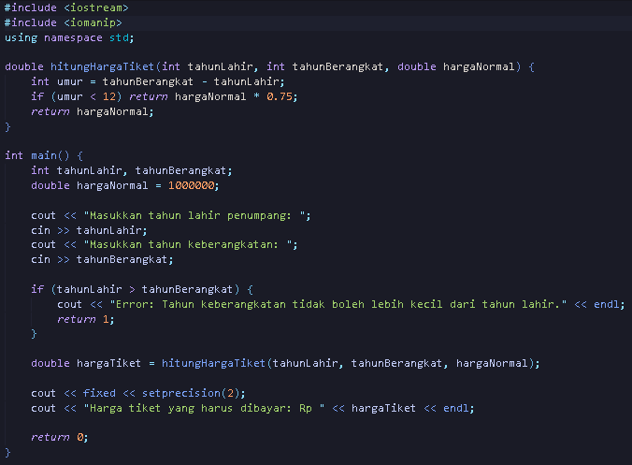

OUTPUT

